**Chapter 12 Hands on Project**

**CSC 133**

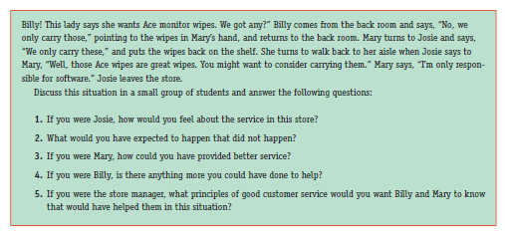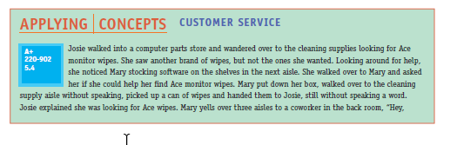Read the given scenario and answer the following question considering you as a given

person (Discuss if needed). Page no(546)

Answers:

1. I will be upset.

2. I was expecting to be helped at the store, but was not provided any useful information.

3. If I don’t have the answer to the customers’ question, as least go find someone else or point to some direction where the customer might get better help.

4. Check the inventory and loop up the computer system; report to the store manager what Mary suggested

5. Try to help customer as much as you can, if you don’t know the answer, go find it

Page no.(570)

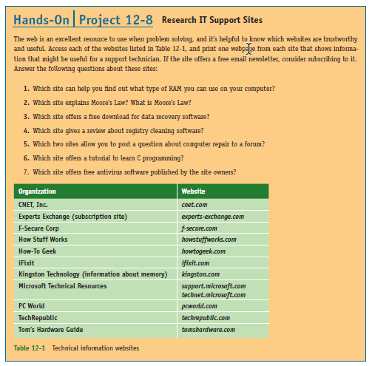

1. 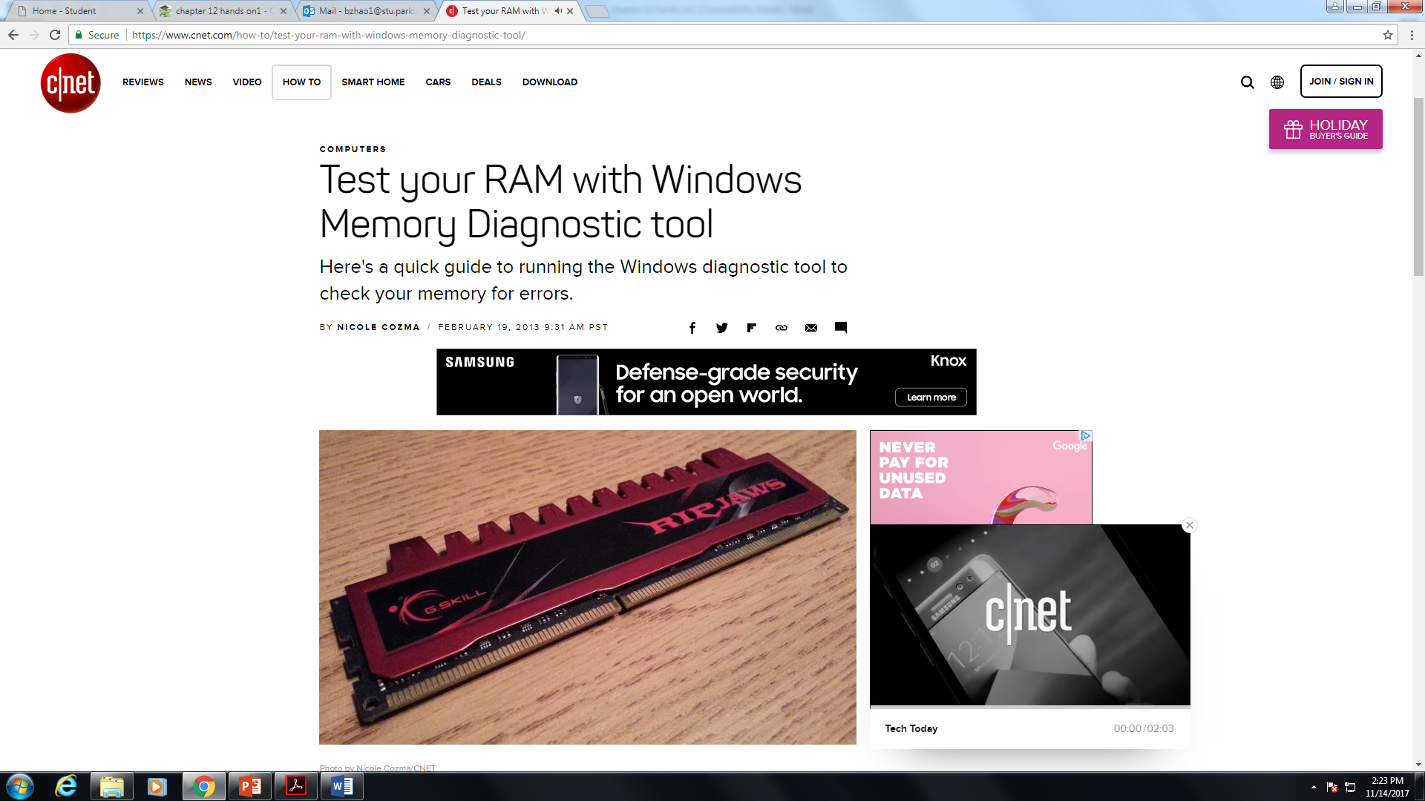

2. 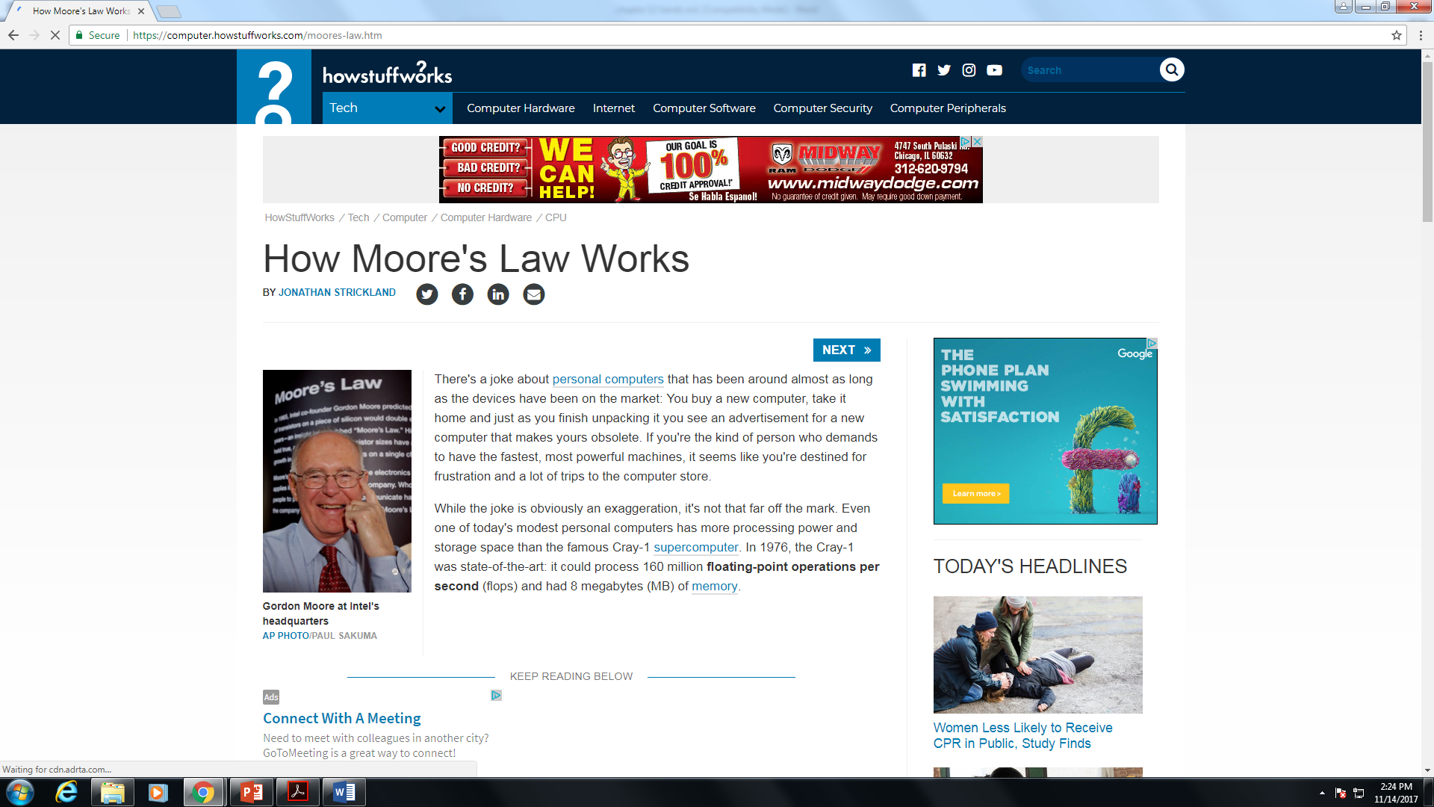

3.

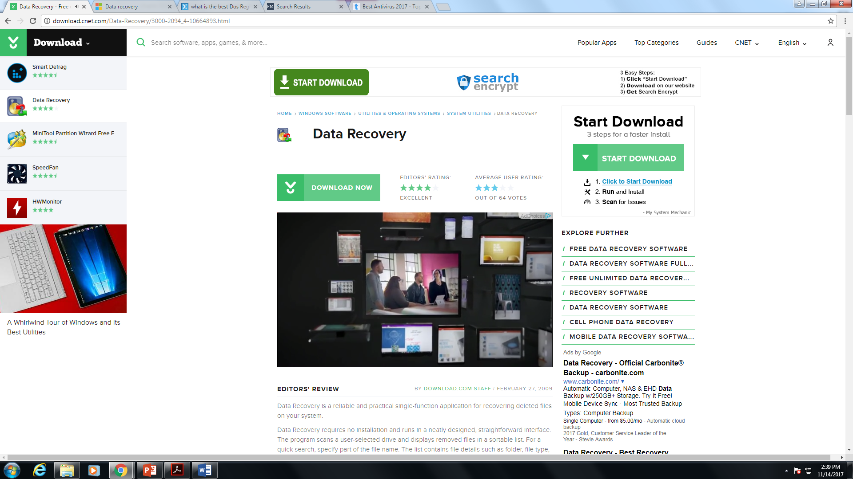

4.

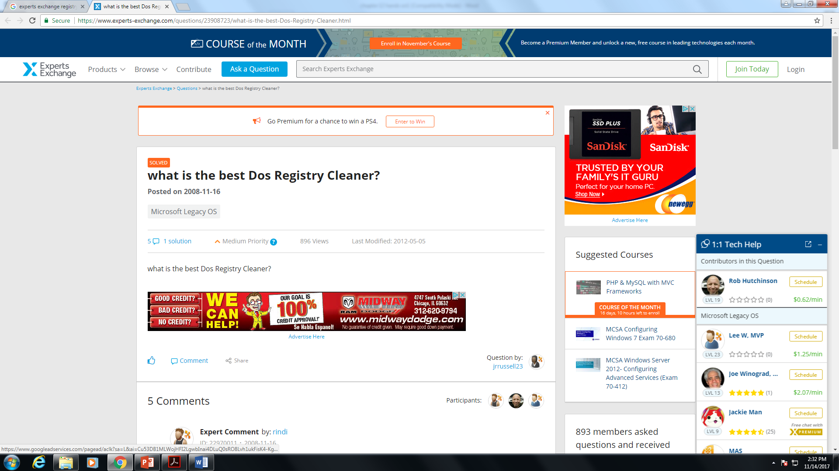

5.

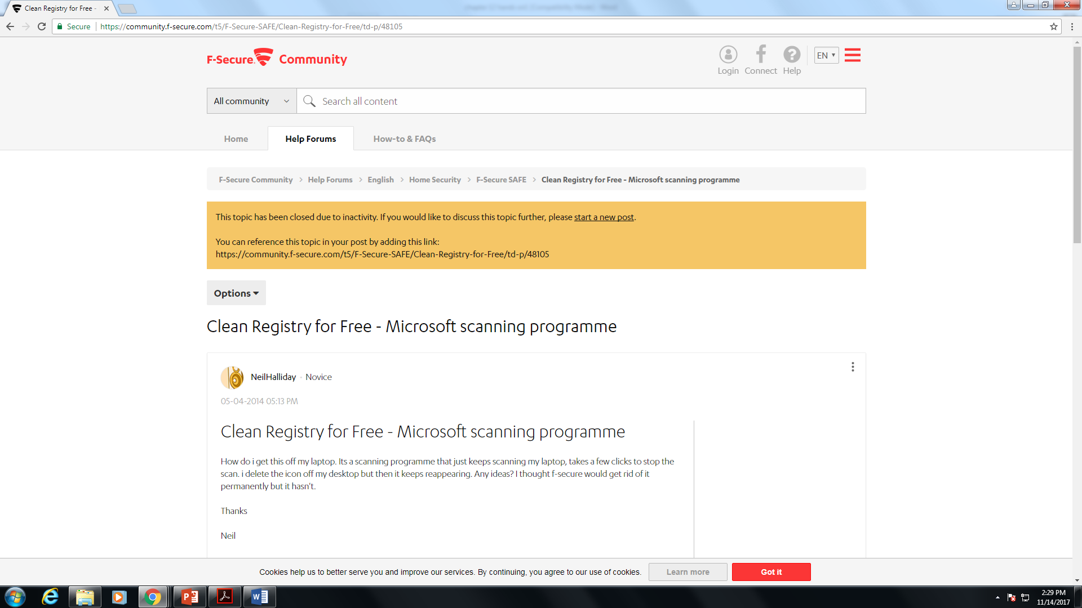

6.

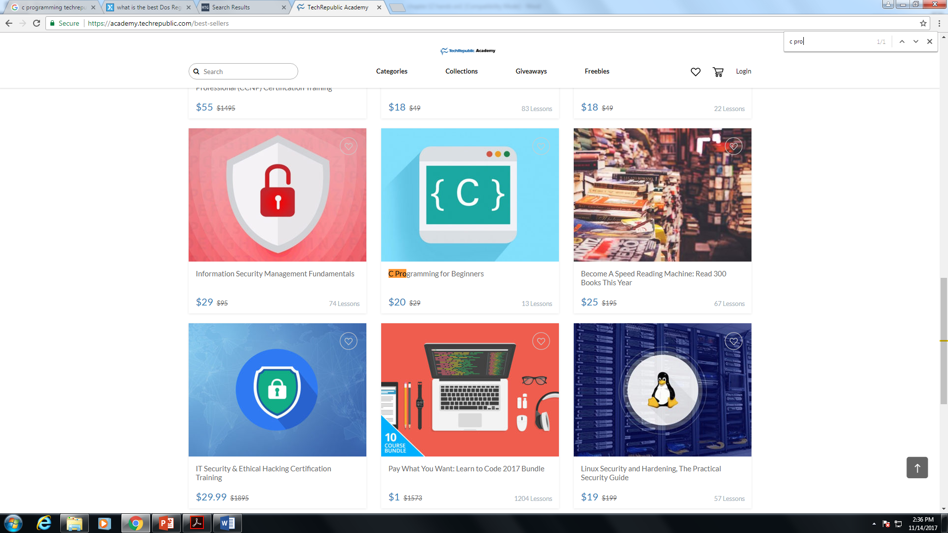

7.

